Monitoring and Escalation Procedures
Originator: | Sender De La Roca |  | Revision Date: | May 13, 2025
Manager Approval: | Ruben Ybarra |  | Effective Date: | September 24, 2018
 |  |  | Original Date: | September 24, 2018
PURPOSE
During the course of a business day or weekend, issues arise that must be escalated in order to meet the needs of our customers. Timely escalation is critical to ensure expedient problem resolution. Escalation not only includes calls made to notify appropriate personnel to resolve technical issues, but it also includes providing timely and accurate information to management

PROCEDURES
Contents
Overview 3
General Requirements 3
On-line Requirements 3
Escalation Matrix: 6
Batch Requirements 8
Output Requirements 10
Hardware Requirements 12
Monitoring Tools and Procedures 14
PRTG – BEST 15
PRTG – ECS 18
SEV1 – Network 20
Control – M 23
1. Monitoring 23
2. Escalation 31
3. Problem Resolution and the SLA 32

Overview

The instructions in this document serve to provide procedures for proper escalation as approved by management. The key areas are on-line availability, batch, output distribution, hardware, monitoring tools and general requirements.

General Requirements

The Computer Operations department (OPS) is responsible for several different areas which are critical to the success of LACOE’s core business requirements. On-lines, Batch processing, Output Distribution, and Hardware are primary examples. Monitoring tools are installed in the Data Center to properly observe and report any unexpected outages. There may be other areas within Operations that are not covered in the aforementioned sections of the document.

In general, all problems should receive the necessary attention. Operations must escalate any problems with a potential impact to LACOE’s core business requirements to the supervisor or senior person on-site. The supervisor or senior person must ensure that the instructions outlined in this document are followed.

Escalate problems in a timely manner. 15 minutes should be enough time to gather critical information about a problem and make the first call if necessary.

Be prepared with pertinent information about the problem.

Get estimates of resolution for all problems.

Ensure that a REMEDY ticket is generated.

Keep management in the loop. Too much information to management is better than not enough information. Management will provide direction on frequency by which to keep them updated and to which departments to update.

Follow up on all problems. Do not allow and problem to remain for over 1 hour without a status check. Provide the results of the status check to management.

On-line Requirements

LACOE has various Production on-line systems that are monitored by the OPS department. They are all important but the most critical applications are:

BEST

HCM

FIN

HRS

PeopleSoft

These systems must remain active and functional through the defined business day.

If the on-line systems fail, become non-functional, or will be late, OPS must follow the escalation process noted below:

Immediately upon identifying an outage or delay, the operator must inform the supervisor or senior operator on-site with:

Name of on-line system

Time of failure. If the reason for escalation is a possible delay, an estimate of how long the delay will be. Escalation for a delay must be made immediately upon determining that the possibility exists.

Initial assessment of cause

OPS must contact the appropriate on-line support group via telephone and/or emails (Emails only applies for a system that fails during regular business hours). Do not rely on email. If OPS is unable to reach the designated support person, their manager must be called immediately.

While OPS is working with the technician or support person, the supervisor or senior operator must contact the Operations manager. If the Operations manager is not available, contact the Director of Operations.

An email must also be sent to the appropriate support groups. Send email to those groups below as previously stablished. The main support groups are:

Always include:

HELP_DESK

TS Computer Operations

TIS Director: Robert Bayles

Applications to escalate:

LACOE.edu
Contact support and send notification email to:
- WebMaster
- Web_Admin

PeopleSoft
Contact support and send notification email to:
- TS MVS Analysts
- TS MVS Database
- TS ADS PeopleSoft Support
- TS Enterprise Computing Services
- TS Network Services

HRS
Contact support and send notification email to:
- HRS_PRODUCTION_TEAM
- TS Enterprise Computing Services
- TS Network Services

Network
Contact support and send notification email to:
- CircuitNotification

Server
Contact support and send notification email to:
- TS Enterprise Computing Services

Mainframe
Contact support and send notification email to:
- TS MVS TECH SUPPORT
- TS MVS Analysts
- TS MVS Database

BEST:
Contact support and send notification email to:
- TISplatform-erp@lacoe.edu

During normal business hours, the Help Desk is responsible for all escalations. OPS will call the Help Desk to inquire if they are aware of the issue as redundancy. If they are not aware of the issue send an email to their corresponding groups to notify them of the alert. The Help Desk must initiate a REMEDY ticket.

After hours 5:00PM – 7:00AM, OPS will be responsible to start the escalation process in the event of an outage or any issues which will impact our daily operations.

The OPS supervisor or Senior Computer Operator will ensure that all escalations and follow ups and updates are done in a timely manner. OPS will also be responsible to generate a Help Desk ticket with all the necessary information as a P3 ticket.

Per the Emergency Contacts for System Problems memo, authorized AD&S personnel must contact the School Financial Services (SFS) functional administrators. Please see the Escalation Matrix below for further contact requirements.

The Operations manager will contact the Assistant Director of Operations as necessary.

Escalation Matrix:
Lead/Contact | Backup Contact | Notification Distribution List |  | Problem
Robert Bayles  Phone Call  (562) 458-0863 | Robert Dotson  (562) 383-3711  Ruben Ybarra  (562) 355-6109  Phone Call | Gabriel Leung*  Jenny Zermeno**  Nkeiruka Benson***  Khai Nguyen  Abir Chakraborty | (310) 210 0566  (626) 665 5053  (310) 365 2716  (626) 319-3158  (310) 218-3882 | PeopleSoft Online Not up as scheduled—notification as soon as known but no later than 5:30 a.m.
Robert Bayles  Phone Call | Robert Dotson  Ruben Ybarra  Phone Call | Gabriel Leung*  Jenny Zermeno**  Nkeiruka Benson***  Khai Nguyen  Abir Chakraborty | (310) 210 0566  (626) 319 3158  (310) 365 2716  (626) 319-3158  (310) 218-3882 | BEST Advantage FIN Online Not up as scheduled—notification as soon as known but no later than 5:30 a.m.
Robert Bayles  Phone Call | Robert Dotson  Ruben Ybarra  Phone Call | Yumeka Seabrooks*  Jocee Panganiban**  Scott Welker***  Nkeiruka Benson****  Khai Nguyen  Abir Chakraborty | (951) 315 8727  (909) 641-8109  (562) 459-0515  (562) 708-1380  (310) 365 2716  (626) 319-3158  (310) 218-3882 | HRS Online Not up as scheduled—notification as soon as known but no later than 5:30 a.m.
Robert Bayles  Phone Call | Robert Dotson  Ruben Ybarra  Sender  De La Roca  (562) 745-4781  Phone Call | Jenny Zermeno*  Gabriel Leung**  Nkeiruka Benson***  Khai Nguyen  Abir Chakraborty | (626) 665 5053  (310) 210 0566  (310) 365 2716  (626) 319-3158  (310) 218-3882 | B-warrants and warrant registers not produced and ready for SFS Support Services by 5:30 a.m.
Robert Bayles  Special E-Mail to each work email address | Robert Dotson  Ruben Ybarra  Sender  De La Roca  (562) 745-4781  Phone Call | SFS_Support_” Yumeka”  SFS_Payroll_Manager  Raymond Bribiesca  Khai Nguyen  Abir Chakraborty | (951) 315 8727  (562) 922-6041  (626) 319-3158  (310) 218-3882 | HRS Time Reports not produced and ready for SFS Support Services 6:00 a.m.
Robert Bayles  Phone Call | Robert Dotson  Ruben Ybarra  Sender  De La Roca  (562) 745-4781  Phone Call | Yumeka Seabrooks*  Scott Welker***  Nkeiruka Benson****  Khai Nguyen  Abir Chakraborty | (951) 315 8727  (562) 459-0515  (562) 708-1380  (310) 365 2716  (626) 319-3158  (310) 218-3882 | A-warrants and warrant registers not produced and ready for SFS Support Services 7:00 a.m.
Khai Nguyen  Special E-Mail to each work email address | Robert Dotson  Ruben Ybarra  Phone Call | SFS GL Group  SFS RAD Group  TS ADS PS Reporting Support | Email  Email  Email | PeopleSoft reports not available on RAD by 8 a.m.
Robert Bayles  Phone Call | Robert Dotson  Ruben Ybarra  Phone Call | Yumeka Seabrooks*  Scott Welker*** | (951) 315 8727  (562) 459-0515 | HRS reports not available on RAD by 8 a.m.
Robert Bayles  Special E-Mail to each work email address | Robert Dotson  Ruben Ybarra  Sender  De La Roca  (562) 745-4781  Phone Call | SFS_Support_Services  SFS_Payroll_Manager  SFSEmployeeServices  Yumeka Seabrooks*  Scott Welker*** | Email  Email  Email  (951) 315 8727  (562) 459-0515 | HRS Reports not produced and delivered after one day
Robert Bayles  Phone Call | Robert Dotson  Ruben Ybarra  Phone Call | Christina Hill*  Anthony Diep**  Nkeiruka Benson***  Khai Nguyen  Abir Chakraborty | (323) 313-2384  (323) 906-2984  (310) 365 2716  (626) 319-3158  (310) 218-3882 | BEST BUD Application
Robert Bayles  Phone Call | Robert Dotson  Ruben Ybarra  Phone Call | Jenny Zermeno*  Gabriel Leung**  Nkeiruka Benson***  Khai Nguyen  Abir Chakraborty | (626) 665 5053  (310) 210 0566  (310) 365 2716  (626) 319-3158  (310) 218-3882 | BEST FIN Application
Robert Bayles  Phone Call | Robert Dotson  Ruben Ybarra  Phone Call | Yumeka Seabrooks*  Scott Welker***  Nkeiruka Benson****  Khai Nguyen  Abir Chakraborty | (951) 315 8727  (562) 459-0515  (562) 708-1380  (310) 365 2716  (626) 319-3158  (310) 218-3882 | BEST HCM Application

OPS must contact the support technician within 15 minutes of the initial call to obtain an estimated resolution time. These times must be provided to the supervisor or senior operator for immediate escalation to management as well as to the Help Desk. If the initial estimate for the problem resolution is within 1 hour, the operator must contact the support person within 30 minutes after the estimate to validate that the estimate is still on target.

For major outages (more than an hour), hourly status must be provided unless management determines otherwise. In which time, management would provide an appropriate status frequency for the problem. SFS (School Financial Services) must be kept informed. The supervisor or senior operator will check with Operations management prior to issuing a status to SFS.

Upon problem resolution:

The operator must obtain details from the technician and provide them to the supervisor or senior operator. The details required are:

Time that the problem was resolved

Cause of the problem

What was done to fix the problem

The supervisor or senior operator will provide this information to operations management. Also, they will follow-up to ensure that the REMEDY ticket is updated and possible closed.

The operations manager will provide the information to the TIS Director of Operations and will provide direction on other notification to other departments as necessary.

Batch Requirements

Batch cycles are processed daily to update databases, perform maintenance, and produce output. Both the BEST and IBM systems process batch cycles that are critical to LACOE’s core business. These cycles are:

HRS Batch starts at 19:00 Monday – Friday and 15:00 on Saturdays

HCM Batch starts at 18:30 Monday – Friday (No batch on Saturdays)

PeopleSoft Batch starts at 18:30 Monday – Friday and 15:00 on Saturdays

FIN Batch starts at 18:30 Monday – Friday (No batch on Saturdays)

Their online availability is:

Human Resources Systems (HRS)

Monday through Friday, 7:30 a.m. to 7:00 p.m.

Saturday, 8:00 a.m. to 3:00 pm.

Human Capital Management (HCM)

Monday through Friday, 6:30 a.m. to 6:30 p.m.

Saturday, 8:00 a.m. to 3:00 pm.

PeopleSoft

Monday through Friday, 6:30 a.m. to 6:30 p.m.

Saturday, 8:00 a.m. to 3:00 pm.

Financial (FIN)

Monday through Friday, 6:30 a.m. to 6:30 p.m.

Saturday, 8:00 a.m. to 3:00 p.m.

For batch abends or jobs ending on errors:

Allow 15 minutes to hear back from the Operations Analysts (OA) or support person before calling.

If a batch jobs fails and a call is required:

Call OA primary support no more than 15 minutes after the ABEND or job error. If the primary on call person does not answer, leave a message and allow 5 minutes for a call back. After no response in 5 minutes, call the secondary OA on call person. Escalate to the manager of that area if the primary or secondary support person is not reached within 10 minutes.

OAs cell numbers during their normal shift hours. This is only from Monday 06:30 AM – Saturday 05:30 AM (*Except Holidays)

❖ Tim Carter From 6:30 AM - 3:00 PM 562 745-8766

❖ If no answer: escalate to Manager: Ruben Ybarra - (562) 355-6109

When support is reached, inform them that a follow up call will be placed within 30 minutes for an estimated time to resolve the issue.

Inform the supervisor or senior operator.

Follow up within 30 minutes after initially reaching support personnel.

If the support person estimates the resolution to take over 60 minutes and the job is in the critical path to the on-lines, the supervisor or senior operator must call the Operations manager. Be prepared to provide times and estimates. The Operations manager will provide direction on other calls to be made as necessary. If the Operations manager is not available, contact the Director of Operations. OPS must initiate a REMEDY ticket. If not, the supervisor or senior operator will ensure that one is generated. For ABENDS lasting more than an hour, OPS must call the support technician hourly for status updates. Operations management will determine the frequency by which to keep them informed. (School Financial Services) must be kept up to date as well. The supervisor or senior operator will check with Operations management prior to contacting SFS.

If jobs in the critical path are processing excessively longer than expected, but there are no ABENDS, the same escalation procedures must be followed. The critical path in this case is defined as any job in the processing path to bringing up the on-lines. Escalation for delays or extended batch processing must be made immediately upon determining that the possibility exists.

Call primary support on call if a job exceeds 30 minutes of its known average duration. If the on call person does not answer, leave a message and allow 5 minutes for a call back. After no response in 5 minutes, call the secondary person. Escalate to the manager of that area if the primary or secondary support person is not reached with 10 minutes.

When a support person is reached, inform them that a follow up call will be placed within 30 minutes to obtain an assessment of the situation.

Inform the supervisor or senior operator.

Follow up within 30 minutes after initially reaching support personnel.

If the support person determines volume is the cause and the extending duration is justified, and the on-lines may be late, the supervisor or senior operator must call the Operations manager. Be prepared to provide times and estimates. The Operations manager will provide direction on other calls to be made as necessary. If the Operations manager is not available, contact the Director of Operations. OPS must initiate a REMEDY ticket. If not, the supervisor or senior operator will ensure that one is generated. Operations management will determine the frequency by which to keep them informed. (School Financial Services) must be kept up to date as well. The supervisor or senior operator will check with Operations management prior to contacting SFS.

*** Note *** Remember that delays in batch will most likely mean a delay in output

distribution. While getting estimates, be prepared to provide management with information regarding critical output being delayed as well.

Upon problem resolution:

OPS must obtain details from the technician and provide them to the supervisor or senior operator. The details required are:

Time that the problem was resolved

Cause of the problem

What was done to fix the problem

The supervisor or senior operator will provide this information to operations management. Also, they will follow-up to ensure that the REMEDY ticket is updated and closed if approved.

The operations management will provide the information to the Director of Operations and will provide direction on other notification to other departments as necessary.

Output Requirements

Output is produced from both IBM and BEST systems in either hardcopy or electronic form. Some of the various types output are:

A-Warrants

B-Warrants

Advices

Reports

Electronic report files to RAD and Mobius

A-Warrants are due out by 7:00 am and B-Warrants are due out by 6:00 Am. Electronic report files sent to RAD must be posted by 09:45AM. Most hardcopy output must be distributed to districts, and must be ready for Jet mail pickup Monday through Friday by 0700. RAD is an on-line reporting system that must have its electronic files by 09:00. If any output is to be late, the following escalation procedures must be followed:

Determine the cause of the delay (Hardware or software).

If software, follow instructions outlined in the Batch Requirements section. Remember that a delay in batch processing, in most cases, could mean a delay in output distribution.

If Hardware, follow instructions outlined in the Hardware Requirements.

*** Note *** When in doubt, escalate any problems to management. More

information is always better than not enough information.

Hardware Requirements

The Computer Operations department is responsible for many pieces of equipment. This hardware is housed in the data center and part of the core business requirements. Some of critical hardware equipment is:

IBM Mainframe

DS8800

Canon Printers

Tape Libraries

Servers

Network

Environmental units.

Any hardware problems should be escalated immediately. Should any hardware issues arise, the following steps must be followed:

Identify all pertinent information regarding the failed hardware including hardware type, error messages, time of problem, etc…

Determine whether to call the Technical Support on-call person, the vendor support center for the particular hardware or Building Services.

Provide all pertinent information needed for a proper and expedient diagnosis of the problem. Always get estimates from vendors or the Technical Support group as to when to expect a callback or on-site support. Should the estimate given exceed 30 minutes, escalate call to the next level of management.

Escalate the problem to the supervisor or senior person on-site and provide all details of the problem and determine course of action.

If the problem requires for staff to evacuate the premises, follow all evacuations procedures and escalate to OPS manager and Director immediately after you are in safe surroundings.

Call Security desk at 562-922-6666 as well and let them know of the situation.

For all other situations, OPS must initiate a REMEDY ticket with critical information including timelines, names, and thorough error description.

If the problem has a potential to cause missed deadlines for output distribution, or if the resolution is estimated to take over 60 minutes, the supervisor or senior operator must call the Operations manager. Be prepared to provide times and estimates. The Operations manager will provide direction on other calls to be made as necessary. If the Operations manager is not available, contact the Director of Operations. Remember that the OPS must initiate a REMEDY ticket. If not, the supervisor or senior operator will ensure that one is generated. For major hardware outages (more than an hour), OPS must call the support technician hourly for status updates.

Operations management will determine the frequency by which to keep them informed (School Financial Services) must be kept up to date as well. The supervisor or senior operator will check with Operations management prior to contacting SFS.

Upon problem resolution:

The operator must obtain details from the technician and provide them to the supervisor or senior operator. The details required are:

Time that the problem was resolved

Cause of the problem

What was done to fix the problem

The supervisor or senior operator will provide this information to operations management. Also, they will follow-up to ensure that the REMEDY ticket is updated and if closed if approved.

The operations management will provide the information to the Assistant Director of Operations and will provide direction on other notification to other departments as necessary.

Always remember to fill out a Computer Malfunction Report (CMR) for the hardware issue.

Monitoring Tools and Procedures
All Monitoring tools will have a RED highlighted message/area in the map when an issue occurs. OPS will only invoke the escalation process when a RED alert is displayed in the monitoring map.
NOTE: Management has agreed that between the hours 7:00PM – 6:30AM, OPS could wait
up to 30 minutes to see if the alert disappears. If alert is on the map for 30 minutes, start escalation process.

Response
Priority | Expected Response time is: | Expected Resolution time: | Escalation Time:
Critical | Within 30 minutes | ASAP | Immediate | 15 minutes: Call Secondary on call if no response. | 30 minutes: Call Manager if no response.
Warning | Within 1 business day | Next business day | Email notification only | Email notification only | Email notification only
Ignore | Within 1 business day | Next business day | No Action required. | No Action required. | No Action required.
Normal | No Action required. | No Action required. | No Action required. | No Action required. | No Action required.

Business Hours | Monday through Friday, 6:30 a.m. to 7:00 p.m.  Saturday, 8:00 a.m. to 3:00 p.m. | P1 Incidents activate on-call procedures  Response must be human (i.e., non-automated)

PRTG – BEST
- Logon to: https://vpn.best.lacoe.edu/best
- Enter your Pulse secure username and password.
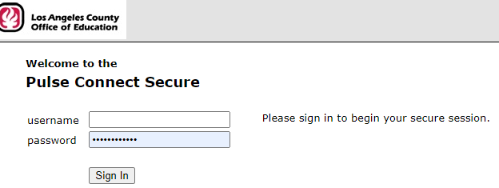
- Start Pulse Secure. (The client must be installed in your computer to work)
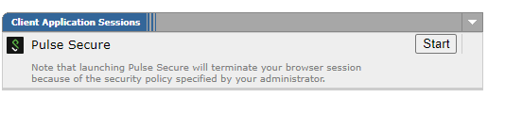
You may have either one of this sessions:

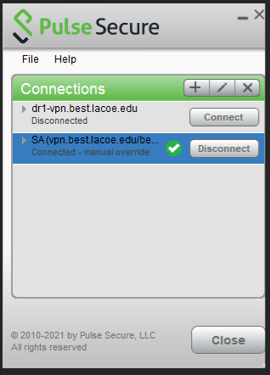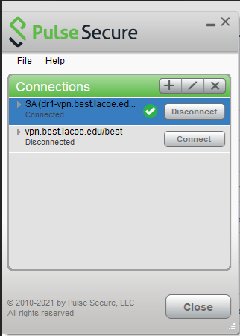

- Make sure that pulse secure is connected. Check on your task bar that the pulse secure ICON has a green arrow mark on it like this:
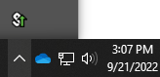

- Launch the Production and Training PRTG Map from the main Web Bookmarks:
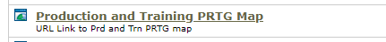

- The PRTG map will appear.
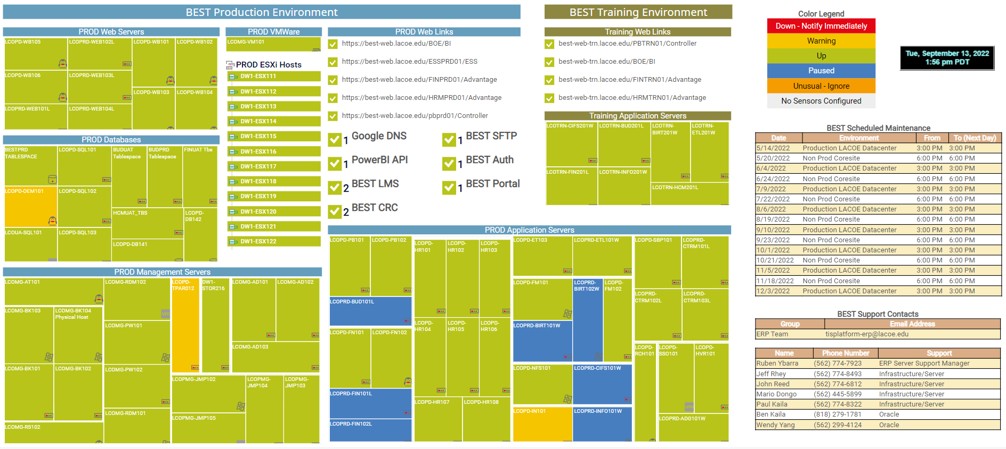

- Any Red alert on this map needs to be escalated as follows:

NOTE: Management has agreed that between the hours 7:00PM – 6:30AM, OPS could wait up to 30 minutes to see if the alert disappears. If alert is on the map for 30 minutes, start escalation process.

  - Check the section on the map labeled: “BEST Scheduled Maintenance”
  - If the red alerts fall on a scheduled Maintenance window you can ignore the alerts. If any alerts are present during these set times, the ERP team should be monitoring PRTG for any issues and will handle them as needed.
  - For any other alerts outside maintenance windows follow the next steps:
  - During normal business hours 7:00AM – 5:00PM Monday - Friday, the Help Desk is responsible for all escalations. OPS will call the Help Desk to inquire if they are aware of the issue as redundancy. The Help Desk must initiate a REMEDY ticket and do any follow ups. If needed, OPS team will send an email to TISplatform-erp@lacoe.edu with a short description of the alerts.
  - For after hours: 5:00PM – 7:00AM, OPS will be responsible to start the escalation process.
  - OPS team will send an email to TISplatform-erp@lacoe.edu with a short description of the alerts and start a calling procedure.
  - For any Server alerts. Call the primary on-call person for Infrastructure.
  - For any Database Alerts, Call the primary on-call person for Oracle.
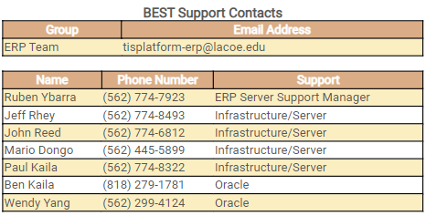
  - OPS receives every Friday an email with the primary and secondary ERP on call personnel and we use that email to update our announcements screen.
  - Call primary support on call if the alert remains for 30 minutes in PRTG.
  - If the on call person does not answer, leave a message and allow 5 minutes for a call back. After no response in 5 minutes, call the secondary person. Escalate to the manager of that area if the primary or secondary support person is not reached with 10 minutes.
  - When a support person is reached, inform them that a follow up call will be placed within 30 minutes to obtain an assessment of the situation.
  - Inform the OPS Supervisor or Senior Operator.
  - Follow up within 30 minutes after initially reaching support personnel.
  - If the support person determines that the problem resolution will take more than one hour to be resolved, call the ERP Server Support Manager (ESSM). Be prepared to provide times and estimates. The ESSM will provide direction on other calls to be made as necessary. If the ESSM is not available, contact the Director of Operations. The ERP team will be responsible for opening a Remedy ticket and all further escalations
  - The ESSM or ERP team will ensure that all escalations, follow ups and updates are done in a timely manner.

PRTG – ECS
- Logon to the ECS PRTG site:
https://prtg-main.internal.lacoe.edu/index.htm
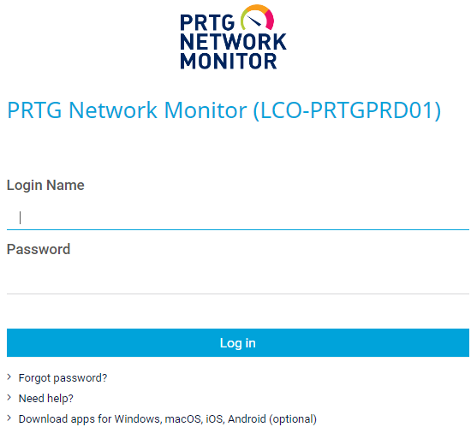
- Use the UserID and password provided by ECS and located in our check off sheets.
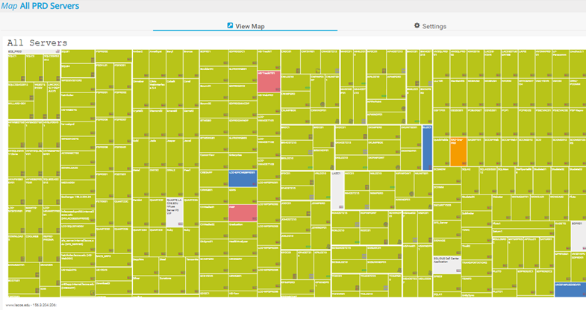
- Any Red alert on this map needs to be escalated as follows:

NOTE: Management has agreed that between the hours 7:00PM – 6:30AM, OPS could wait up to 30 minutes to see if the alert disappears. If alert is on the map for 30 minutes, start escalation process.

  - During normal business hours 7:00AM – 5:00PM Monday - Friday, the Help Desk is responsible for all escalations. OPS will call the Help Desk to inquire if they are aware of the issue as redundancy. The Help Desk must initiate a REMEDY ticket and do any follow ups.
  - For after hours: 5:00PM – 7:00AM, OPS will be responsible to start the escalation process.
  - OPS team will send an email to ECS Team: TSEnterpriseComputingServices@lacoe.edu with a short description of the alerts and start a calling procedure.
  - OPS receives every Friday an email with the primary and secondary ECS on call personnel and we use that email to update our announcements screen.
  - Call primary support on call if the alert remains for 30 minutes in PRTG.
  - If the on call person does not answer, leave a message and allow 5 minutes for a call back. After no response in 5 minutes, call the secondary person. Escalate to the manager of that area if the primary or secondary support person is not reached with 10 minutes.
  - When a support person is reached, inform them that a follow up call will be placed within 30 minutes to obtain an assessment of the situation.
  - Inform the OPS Supervisor or Senior Operator.
  - Follow up within 30 minutes after initially reaching support personnel.
  - If the support person determines that the problem resolution will take more than one hour to be resolved, call the ECS Server Support Manager (ESSM). Be prepared to provide times and estimates. The ESSM will provide direction on other calls to be made as necessary. If the ESSM is not available, contact the Director of Operations. The ECS team will be responsible for opening a Remedy ticket and all further escalations
  - The ESSM or ECS team will ensure that all escalations, follow ups and updates are done in a timely manner.

SEV1 – Network
- Logon to SevOne site:

sevone.lacoe.edu/#login

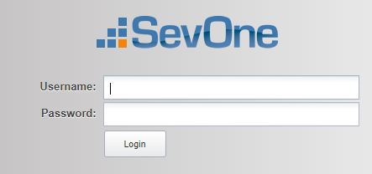

- Use the UserID and password provided by the network team and located in our check off sheets.

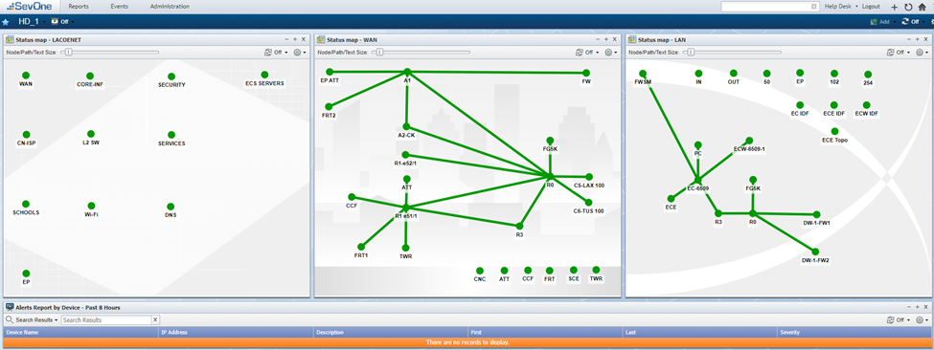

- Any Red alert on this map needs to be escalated as follows:

NOTE: Management has agreed that between the hours 7:00PM – 6:30AM, OPS could wait up to 30 minutes to see if the alert disappears. If alert is on the map for 30 minutes, start escalation process.

  - During normal business hours 7:00AM – 5:00PM Monday - Friday, the Help Desk is responsible for all escalations. OPS will call the Help Desk to inquire if they are aware of the issue as redundancy. The Help Desk must initiate a REMEDY ticket and do any follow ups.
  - For after hours: 5:00PM – 7:00AM, OPS will be responsible to start the escalation process.
  - OPS team will send an email to the Network Team: CircuitNotification@lacoe.edu with the following format:
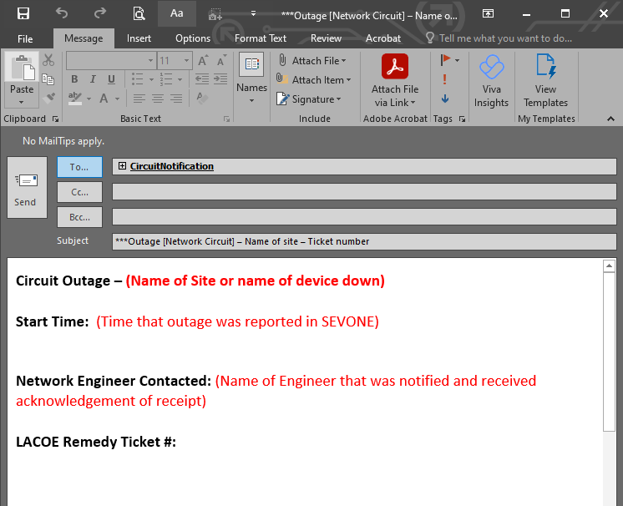
  - OPS receives every Friday an email with the primary and secondary Network Support on call personnel and we use that email to update our announcements screen.
  - Call primary support on call if the alert remains for 30 minutes in PRTG.
  - If the on call person does not answer, leave a message and allow 5 minutes for a call back. After no response in 5 minutes, call the secondary person. Escalate to the manager of that area if the primary or secondary support person is not reached with 10 minutes.
  - When a support person is reached, inform them that a follow up call will be placed within 30 minutes to obtain an assessment of the situation.
  - Inform the OPS Supervisor or Senior Operator.
  - Follow up within 30 minutes after initially reaching support personnel.
  - If the support person determines that the problem resolution will take more than one hour to be resolved, call the Network Manager. Be prepared to provide times and estimates. The Network Manager will provide direction on other calls to be made as necessary. If the Network Manager is not available, contact the Network Director. The Network team will be responsible for opening a Remedy ticket and all further escalations
  - The Network Manager or Network support team will ensure that all escalations, follow ups and updates are done in a timely manner.

Control – M
This section will provide a step-by-step guide to Monitoring and Escalating Issues during the Production Nightly Batch Cycle

- Monitoring
- Check how far job PPAYD671 is on the mainframe batch cycle. This is the mainframe job that connects to the BEST FIN Nightly Cycle. It should be done by 9:30PM and it should run for less than 5 minutes. If that is not the case, monitor the job closely as it will impact BEST. Escalate as needed.

- Logon to: https://vpn.best.lacoe.edu/best
- Enter your Pulse secure username and password.
- Open a Terminal Session to the Prod Jumpbox
- Log in to Control-M for Prod click on the icon below:
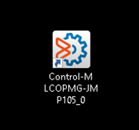
- Once you are there, make sure that you are in the production environment. For Operations it should say “Default Environment” as shown below:

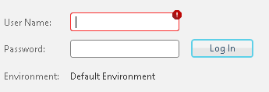

- If you need to check the environment, click on the environment tag in the middle of the screen and it should show you that you are logging into lcoprd-ctrm101l as shown below:

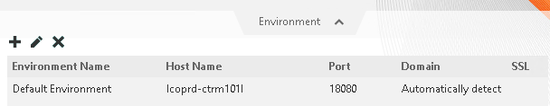

- Enter your user ID and password. They are the same you use to logon to Pulse Secure.
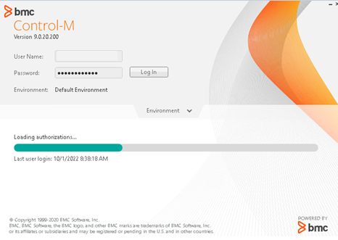

- Once you are in Control-M, Click on Monitoring and then All View Points:

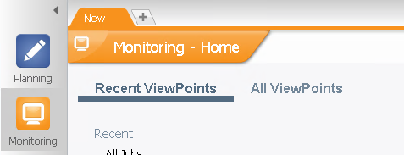

- Click on “All Jobs-NoSub”

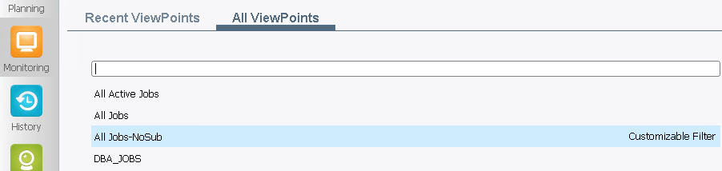

- The next window will appear:

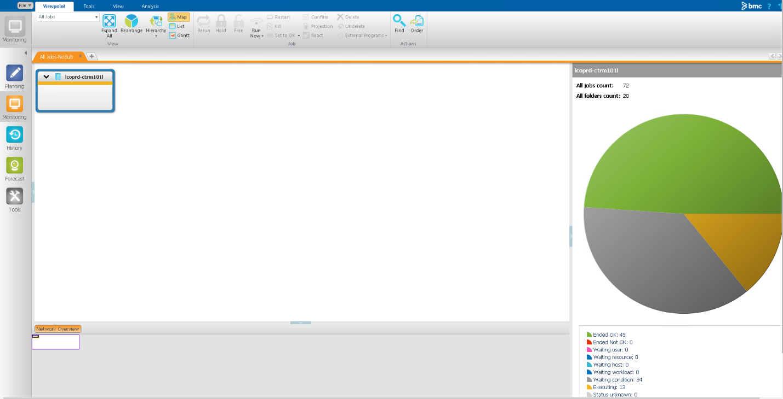

- On the tool bar at the top, click on “Expand All”

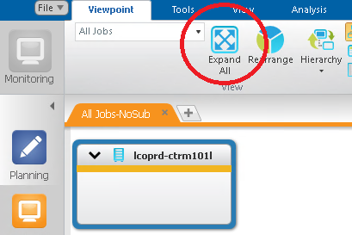

- This will show you all the jobs which are processing at this time.

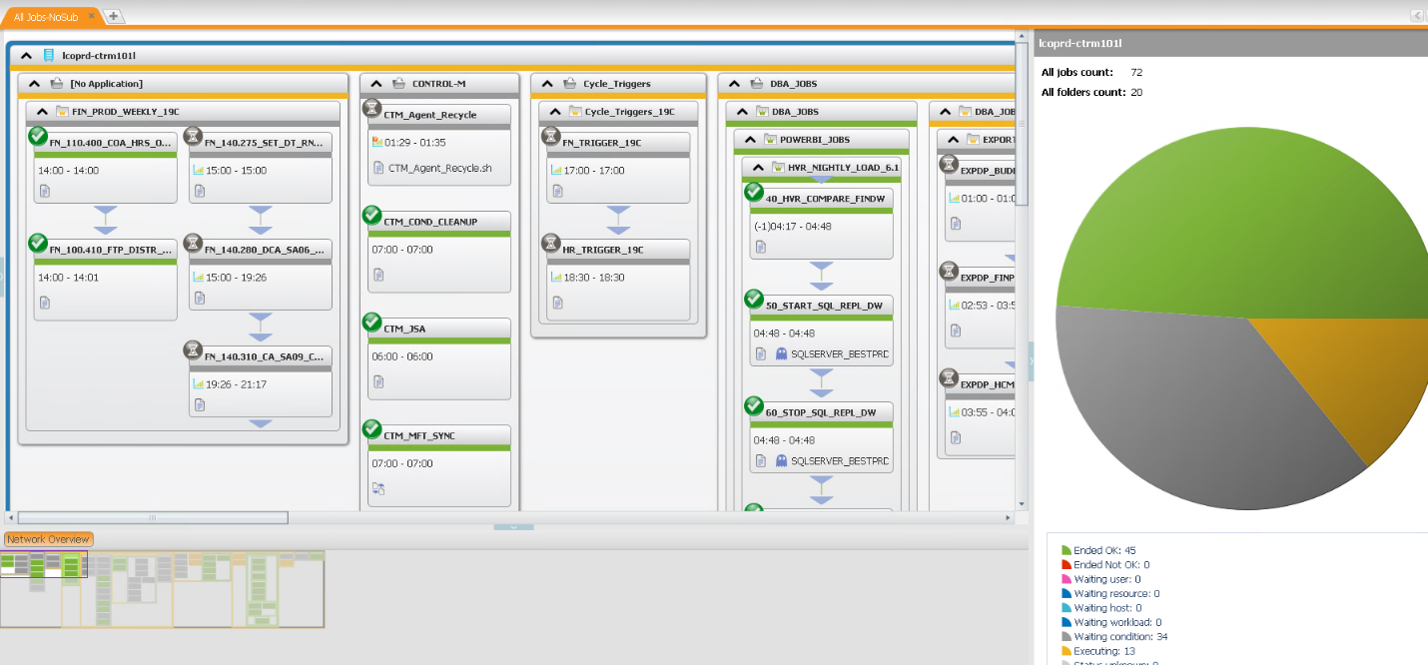

- You will not cause any errors or problems by clicking on the view.
- At the bottom of the screen, look at the network overview

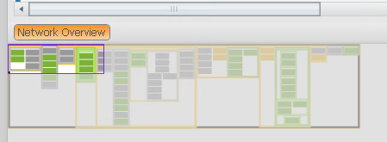

- Here is where you will start looking at what jobs have completed, are running and/or waiting execution.
- During phase one, OPS will only be responsible for monitoring alerts, jobs running a long time and job ending not OK ( RED ) while consulting with the OA on site for guidance.

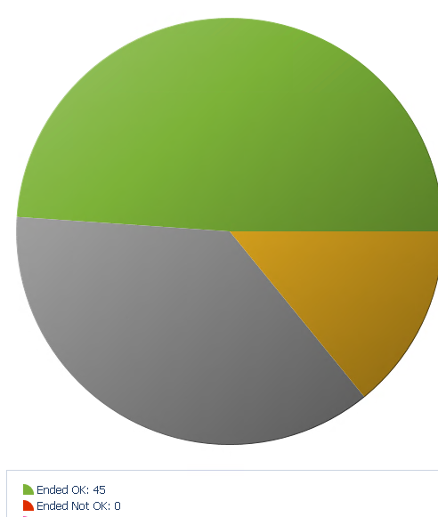

- During phase two, OPS will be responsible for monitoring alerts, jobs running a long time and job ending not OK. ( RED ) and escalating jobs to the OAs for them to take care of the issues. They will show us what we will need to do with each job as recommended by the support team.

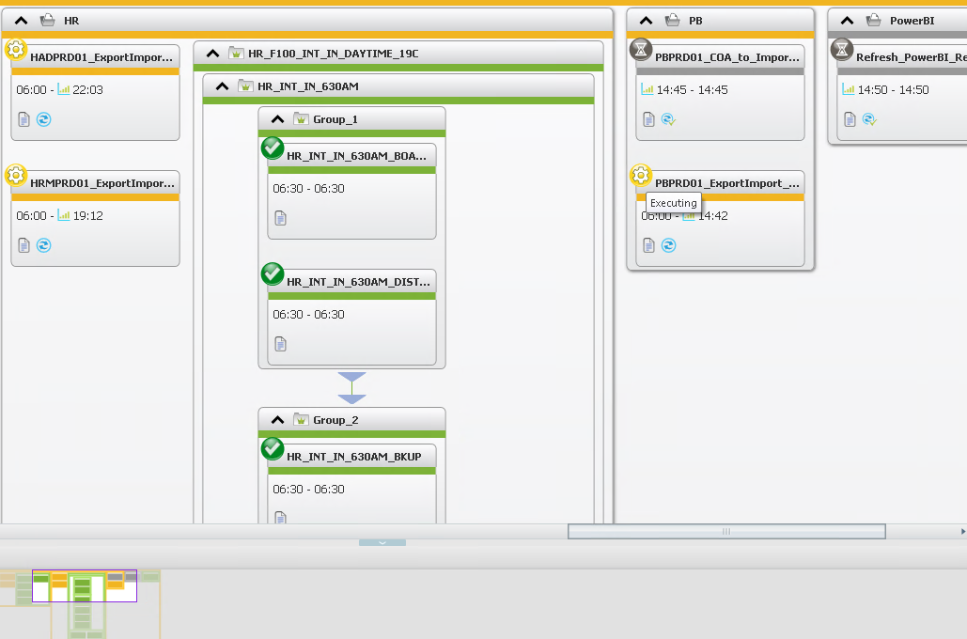

- During phase three, OPS will be fully responsible for monitoring alerts, jobs running a long time and job ending not OK. ( RED ) and escalating to the support groups for instructions on how to handle the job. ( Hold, Free, Rerun or Set to OK )

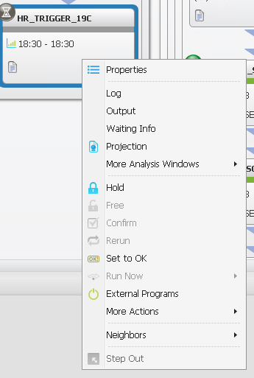

- Another view for alerts, at the top of the screen click on Tools:

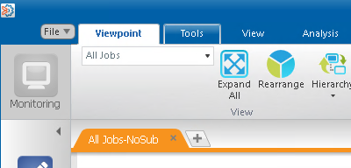

- Then click on Alerts at the top left:

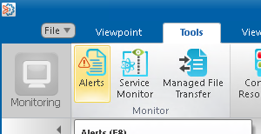

- Click on cancel if you get this message:
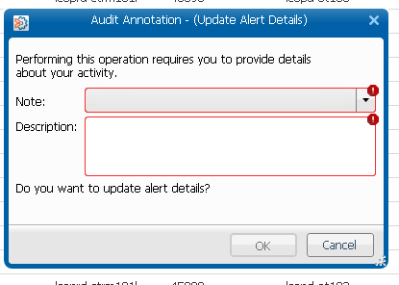

- You will see the following screen. Ignore all previous alerts.

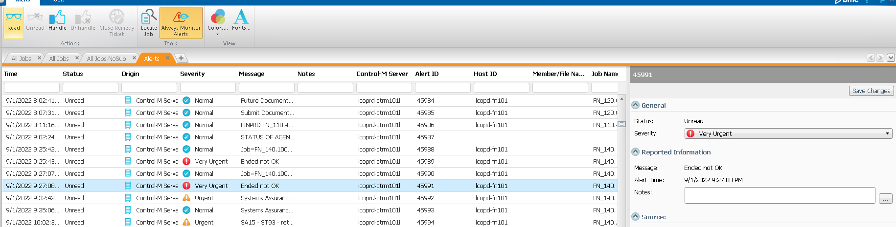

- Click on the arrow pointing down in the TIME column

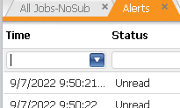

- Select the date you are monitoring jobs:

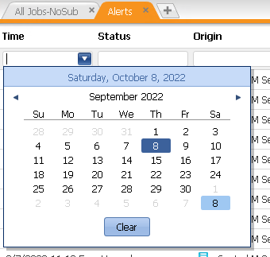

- Click on any alert and see the descriptions on the right window.
- During phase one and two, work with the OAs to understand these windows and if we need to do any escalation

- Escalation
In the event that there is a job failure in Production Control-M:

- Look at the output of the failed job to determine the error. Save the output and copy/paste it to an email.
- Check for the on-call support for the failed job. Make sure the support person On-call, TISPlatform-ERP, and the OAs are included in the email. The oncall list can be found at:

\\lacoe-fsvr\Operations\Comp_Ops\Data_Control\ESCALATION\BEST-ERP Operations Spreadsheet_CURRENT.xlsx

- Send the email and call the Off-Hours Support person and let him/her know that there is a failed job and that an email has been sent with the output. Wait for further instructions.
- After the issue is resolved, respond to any emails accordingly and make sure the corresponding Remedy Incident Ticket is updated and assigned to AD&S.

- Problem Resolution and the SLA
- During the course of resolution, make sure that there is adequate time to meet the SLA:
06:30 Monday thru Friday.
08:00 for Saturday.
- If the SLA will be breached, call the ERP Manager to let him/her know of the situation so they can start a P1 ticket and start the necessary escalations.
- A P1 ticket will alert upper management and SFS that there will be a disruption to the availability of the system in the morning. SFS will need to create an alert on the message board as well.

